**Item Specification**

**Subject:** Biology

**Class:** S.1

**Construct:** A Graduate who uses scientific knowledge and biological concepts to better understand other fields of science and can conserve the environment.

|  |  |  |  |  |  |  |  |  |  |
| --- | --- | --- | --- | --- | --- | --- | --- | --- | --- |
| **Element of construct** | **Competences** | **Level of demand** | **Stimulus type and length** | **Number of st ages** | **Ability levels** | **Type of responses** | **Direction of responses** | **Scoring guide** | **Response time** |
| Appreciates Structures of living organisms | 1.2.b(i) knows the structure and functions of parts of the cell  B(ii) understands the structure and functions of parts of the cell | Medium | Scenario on diversity of living organisms  An image of botanical garden with plants and insects | 3 stages  Reading  Analyzing  Writing | AL | extended | Multiple correct |  | 1 hour |
|  | 1.4.a) identifies the observable external features of common insects |  |  |  |  |  |  |  |  |
|  | 1.4.b) constructs the dichotomous key using characteristic features of common insects |  |  |  |  |  |  |  |  |
|  | 1.5.a) knows the external parts of a typical flowering plant |  |  |  |  |  |  |  |  |
|  | 1.5.b) understands how the structures of monocot and dicot roots, stems, leaves, flowers and fruits suit their functions |  |  |  |  |  |  |  |  |

**Scenario**

1. Your family goes for a picnic at a botanical garden which looks beautiful because of its diversity of plants and insects. You have little sister who is curious and wants to know why plants grow tall and some parts are green, why some plants have brightly colored parts which are often visited by insects and others do not. She is also wondering about how insects are able to fly visiting bright colored parts of some plants.

**Support material**

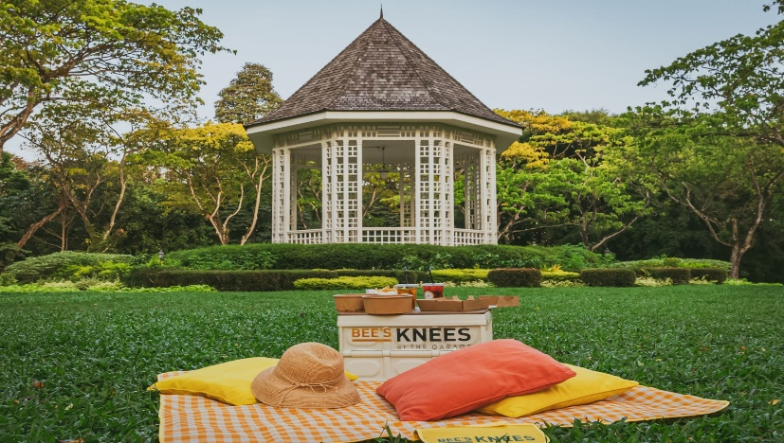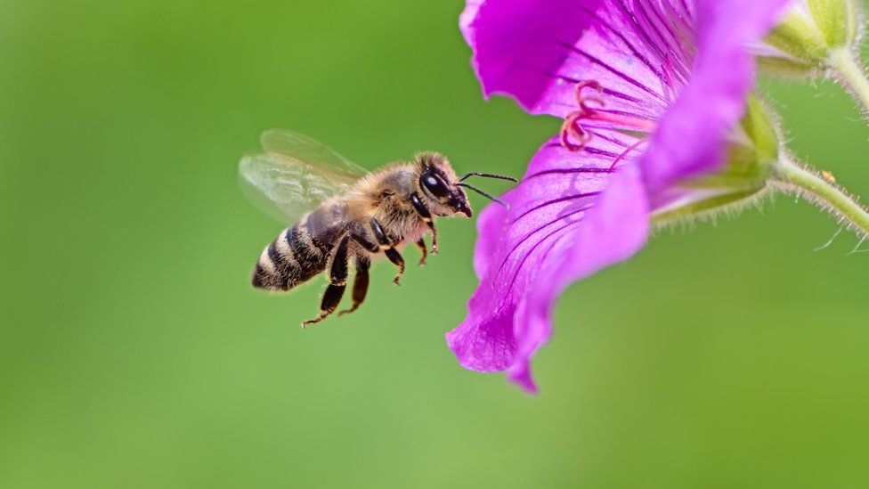

**Task:** Explain to your little sister to satisfy her curiosity.

**EXPECTED RESPONSES:**

***Structures of plant cells:***

* Plants have cells with vacuoles that take in water that expand and also divide making trees grow tall.
* Plants have leaves that contain chloroplasts in their cells that trap sunlight for photosynthesis

***External features of flowering plants:***

* Coloured parts are flowers that attract insects for pollination
* Fruits that attract agents for dispersal

***Monocots and dicots:***

* Different leaf structures (broad leaves, narrow leaves)
* Dull Coloured flowers for monocots and bright colors for dicots
* Venation, parallel (monocot) and net (dicot).

***External features of insects:***

* Insects have wings that enable them fly to flowers
* Legs that enable them to walk
* Have eyes which they use to see flowers